

CESA #4 Title I Directors:
Sherri Torkelson Julie Jensen Laura Veglahn
(608) 786-4855 (608) 786-4828 (608) 786-4814

CESA #4 Title I New Coordinators Orientation and
Fall Network Meeting

September 21, 2012
9:00 – 3:15 p.m.

9:00 Welcome, Introductions, Burning Questions

9:15 DPI: Agenda 2017

9:30 Scientifically-based research: What does this really mean in terms of RtI and ESEA?

10:00 Title I Coordinator Orientation/Review

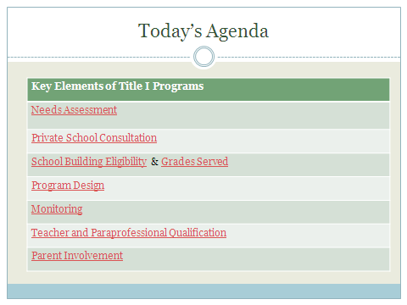

11:15 Title I Guidelines Document: Connecting the Pieces and the Rules

11:45 Lunch and Networking

12:30 New ESEA Application Feedback
Year End Report questions, followup, feedback

12:45 Lara Kain, DPI Consultant – Private School Worksheets and other DPI Updates

1:15 CESA #4 Title I Network Work Plan for 2012-2013
Your 12-13 Title I Binder and Resources
Upcoming Professional Development
Current contacts and programs
Suggested Resources to order for check-out

1:30 2012-2013 ESEA Monitoring

1:45 School Report Cards
Accessing the LDS to view Student Growth Percentiles

2:45 Updates and general information

- Committee of Practitioners
- Wisconsin Title I Association
- Wisconsin Reading Association
- PALS
- Jump-Start: Read for the Record
- Title I Tip of the Week

3:00 Agenda building for Winter Meeting

3:15 Exit Tickets



